**Alone in Africa - Article 1**

MJ Creswick, as a 19 year old, took a leap, followed her heart and took a gap year. She can now say, “I went to Africa, by myself”. How cool. MJ gives Teagan Graham an insight into her 80 days in Africa.

After stopping over in Dubai, she continued on to Malawi where she spent the first seven weeks volunteering. Her days consisted of teaching children in a kindergarten how to speak English, doing after school activities with primary school kids and then helping out in the community. In these seven weeks, she was faced with baboons, always, snakes, crocodiles, hippos, heaps of monkeys, a lot of poverty but a lot of happiness too. She also bumped into a few things us outsiders would not want to find in our bedroom. “Scorpions in my bed, tarantula in my shower”.

Although this might seem to be a list of reasons why you should never go to Africa, MJ says “Even though it’s so corrupt, like, Malawi is the poorest country in the world, but it is still the best country in the world… the people are so happy, it’s just the way of life”.

Something that is quite different to New Zealand is time. Everything is slower over there. “They don’t have watches, they go off the sun - it’s Malawi time. You say let’s meet at 6pm but you wouldn’t bother turning up till 8pm because they just wouldn’t be there. Everything is slower. It taught me to just chill out. I got home and it was just like woah, because it was so on the go”.

MJ told us one of her best moments in Malawi, “The first rain in Malawi for the season, I was there for the end of dry season and the start of rainy season. I remember we were outside, I still remember this song and I downloaded it. Sitting out there with the locals listening to this song… Africa doesn't do weather half hard, sun shining day all of a sudden, a crack of lightning and the heavens open up. It was ridiculous. In NZ, everyone would've got up and run inside trying to cover themselves, but in Africa everyone just got up and danced harder. It was so cool. People were outside with pots trying to gather the water and everyone was so happy because finally the maize would grow”.

MJ’s next chapter in her story of Africa. She ventured out to South Africa for a few days, met up with a group of people and went on an overland tour through South Africa, through a little bit of Botswana into Zimbabwe, zig zagged through Zimbabwe and then into Zambia. They set up camp at every location. MJ said that sleeping in tents in Africa was “Hot... and sketchy because you have to check for snakes” and “In Zimbabwe I had a lioness lay outside of my tent”. I know I’d be terrified, but MJ said “By that time I’d been in Africa for a while and I kind of had that mindset of TIA “This is Africa”. Just be sensible, be safe, like we had a fire lit in Huangdi so that the animals stayed away. There’s no point worrying about it”.   
  
MJ said she could talk about Africa forever, but a golden moment was when she was on a rhino walk in Huangdi. “They have like “DOC” but it’s more intense with AK-47’s which follow you through the bush. We were walking through African bush with snakes and lions and everything dangerous…” “... we were walking past and there's this guy in full army get up, hat and everything, ak-47, Uzi, rhinos right there, African bush around him and then I look down and he’s in Adidas scuffs and bare feet. Classic TIA (This Is Africa).”

Of course, there had to be a few terrifying moments, (as if camping with a lioness wasn’t terrifying enough) “We went on a wee sea kayak to try and see the hippo, and stupidly, we went out at like 5pm. Crocodiles and hippos are most active during twilight. We were in the water in these tiny boats, surrounded by them. We could hear them but we couldn't see them, it was terrifying.’

When Teagan asked MJ why she fell in love with Africa, she said “The people. For sure…” “...Africa gets under your skin, I love the rawness of it”.   
The people are so “funny, outgoing, relaxed, very knowledgeable, very wise”.   
“The indigenous people… they are just full of life, full of song and full of dance, so happy”.

Mj said, without hesitation, that Africa changed her life and she would do it 100 times over. “I’ve always been pretty carefree but still deep down you're kinda like ‘what do I look like?’ ‘she's so much prettier than me’ ‘she's so skinny’ ‘I’m not funny’ ‘nobody likes me’ ‘my life is crap’.

And then I went over and I was just like ‘this is genuine happiness’, this is how I want to be”.

Clearly, Africa did get under Mj’s skin, and she can’t wait to get back over there, aspiring to live there one day. First, she is completing her outdoor education and sustainability course and will work her way into some sort of conservation work in Africa “I really want to do something to do with the fight against poaching”.

Mj became really close with her tour driver in Africa, who sent her this when she left Africa. “I balled my eyes out when I read this”.

“Africa smiled a little when you left, we know you, Africa said. We have seen you and watched you, we can learn to live without you, but we know we need you here. Africa smiled a little when you left, you cannot leave Africa, they said, we are always with you, there inside your head. Our rivers run currents in the swirl of your thumbprint, our drumbeats counting out your pulse. Our coastline, the silhouette of your soul. Africa smiled a little when you left, we are in you, Africa said, you have not left us yet”.

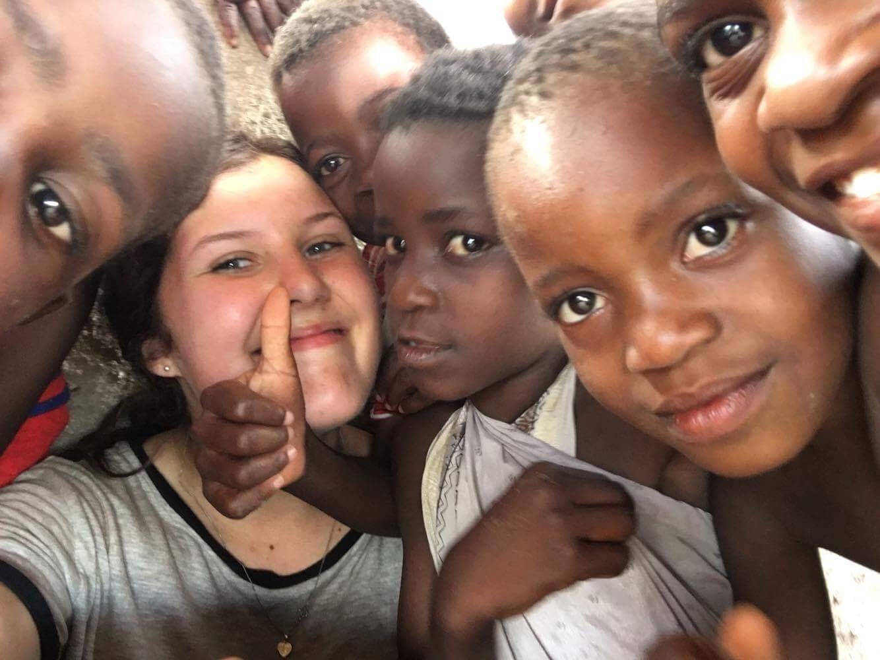

**Take a Leap - Article 2**

If you’re 100% sure what career you want and you're ready to jump straight in, if you don’t need a break and have no interest in travelling or adventure, this article isn’t for you. Otherwise, grab a cuppa, put your feet up and give this a read.

When you're 13 you need to start thinking about your future, at 15 you must have some idea, at 17 you should know what you’re doing. Standard “expectations” for high schoolers are scary, frustrating and stressful. Take maths, sciences, English all the way through, have a good social life, get top marks, never break the rules. Sound familiar?   
  
At 17, life’s reality can hit you in the face. Take that step from high school and you can do *anything*. The big question is, where do you begin? It’s something people often wish they didn't have to think about. Avoid, avoid, avoid. It’s too simple to take the "easy" option, not necessarily the best. Do you feel rushed into making a decision supposedly determining the rest of your life? Olivia Adamson - a former high school student - says she felt “full of fear”, avoiding the “what do you want to do next year?” questions at all costs. “I wasn’t prepared to have a discussion about it when I was still trying to find my feet”.

A survey I conducted got over 80 responses including opinions on gap years and people’s personal experience. To clarify, I’m talking about taking a one year break, before you get back into study or going into full-time work. Most people I surveyed went straight into further study, for reasons like money, commitment, motivation, expectations, pressure. But, 2, 5 or 30 years later, nearly every one of them wish they *had* taken a gap year. One person responded, “I’m at university now, and regret not taking a gap year first. You’re the youngest in your course as most people don’t come from school. I have a student loan which needs paying off so the gap year will have to wait”.

Working’s a great idea. You earn money, get experience and meet new people. But, you have your whole life to work. Is this straight-out-of-school job something you’ll want to make a life from? I don’t know about you but I want to wake up each morning buzzing to see what’s in store for me, not looking forward to the moment I get back into bed. Although my bed is pretty comfy.  
I’m assuming you want an awesome life with an awesome job. Often, that awesome life and job require a qualification or two. Unless you're a tradie or farmer, chances are you're going to spend 100 years paying off your student loan to feel that excitement every morning. Olivia says “Don’t rush, at that age you have the world at your feet!”  
What's one year going to change? Not much if you *don't* take it, but you'll always wonder *what if you had*.

University. A higher qualification, road to a good career and a world of hangovers. It’s the most socially “accepted” option. University’s a place where young people rush into doing degrees they may not use, wasting money on something they shouldn't be.  
I think if you 100% know what you want to study and don’t want a break, go for it. But, if you aren’t sure, take a gap year, gain work experience and maybe even some dollars. *Or,* go overseas and get life experience. As Olivia says, “Expand your knowledge first with life experience and then a textbook”.   
  
When I asked people for advice they’d give to someone in their last year of school I got responses like “Pick somewhere in the world, save and buy a ticket! You’ll never ever regret it I can promise you. There’s no rush to go to uni and start a career, you won’t ‘forget how to study’”. A gap year could have you deep in a journey of self-discovery, withdrawing some doubt about your future. People take gap years because they don’t know what they want to study, or they’ve been in school for 13 years and need a break. “I just wasn’t ready to commit straight after high school. I still needed to learn a lot about myself before I went and threw myself into the next phase of life” Olivia says her gap year was the best thing she could’ve done.   
  
We're always worried about what we're going to lose, not focusing on what we could gain. Studying will give you a qualification and parties. Sounds good. A gap year gives you life experience, time to figure out who you are and what you want to do, a break from study, a chance to see the world. You can still party. That qualification will still be waiting for you. Even better. Olivia says “If you want to travel, don’t suppress that craving because you feel university or a career is more worthwhile, there’s plenty of time later”. If you take a gap year, you’re gaining a lot more than if you don’t.   
  
Sure, you can study first, then travel. Now you’ve got a student loan to pay off and likely job opportunities you don’t want to turn down. You’ve missed your chance for a year's break, it turns into finding time to go on holiday. Olivia highly recommends a gap year, as a “huge learning curve…” “the exposure to the real world can’t be taught through books and lectures”. A survey response read, “Don’t do what you think you *should,* do what you think you’ll *love”.*I’m trying to prove that taking a gap year is okay, in fact much more than okay. Imagine the 96 year old version of you, what would she/he think? How do you want to reflect on your life? I want to look back on the awesome things I’ve seen and done. That doesn’t always mean being caught up in the real world, if you need time to escape, take it. It’s one year.

